# Loopback

If you are reading this, it is probably because you already know loopback is not working and clicked the Help menu to get here. You can skip down below and go right to "How To Test for Loopback ".

Loopback from your router is necessary in Opensimulator if you are going to be running on the Hypergrid. The usual symptom of a broken loopback is being unable to log in to the server after switching to a Public IP or a Dynamic DNS name. If your router does not support loopback, which is common, you can install a simple fix so it can run a viewer. The loopback adapter lets a viewer on the server reach itself, as the loopback via the router is not functioning.

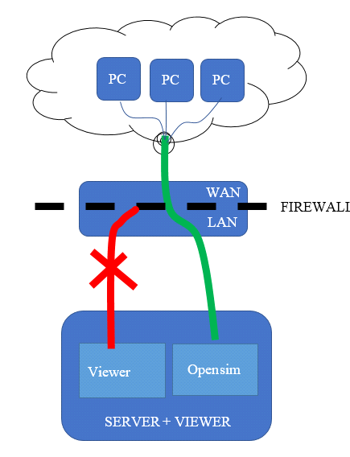

You cannot get to your own PC using the address of outside of the router.

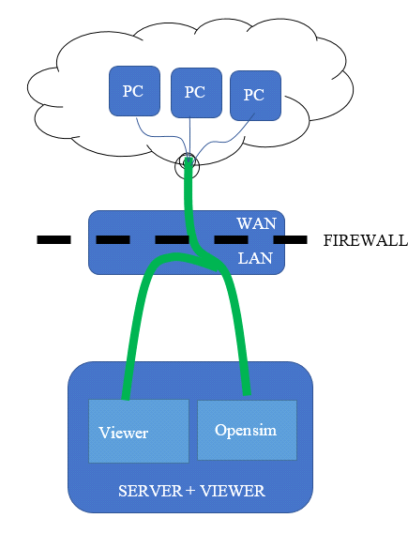

## How to test for loopback

You can manually test for loopback by starting Opensimulator, then use a web browser to navigate to <http://canyouseeme.org>. Enter port 8002 and click Check Port. This must work. if not, fix the port forwarding issues and come back and try this test again. You may need to Open Ports in the firewall or disable it on the PC temporarily.

Do not install a loopback adapter until the above test passes! There is one more test to do to see if you really need to add an adapter.

Your ports are known to be working now, so go get the Public IP of your system from <http://canyouseeme.org>. Use a web browser to navigate to <http://(Public> IP):8002. Use your Public IP where it says (Public IP).

You should get a login page. **If you get this page, loopback is working.** **You do not need to install an adapter** If you do not get this page, loopback is not working in your router.

## Installing the Loopback Adapter

1. Click Start, then type cmd in the search box.
2. When cmd.exe appears, right-click it and choose Run as administrator.
3. In the command prompt, type hdwwiz.exe and press Enter.

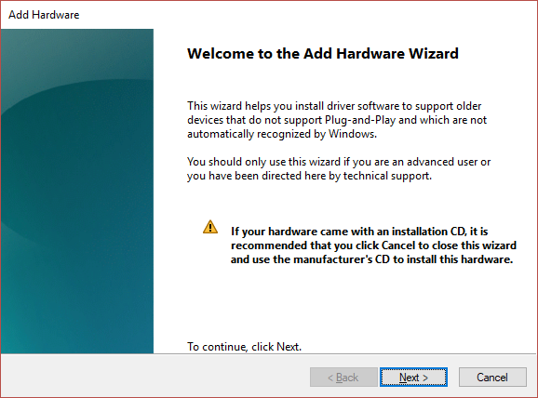

4. Click Next.

5. Select **Install the hardware that I manually select from a list (Advanced),** then click Next.

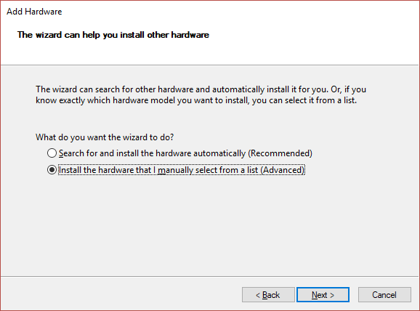

6. Select Network adapters, then click Next.

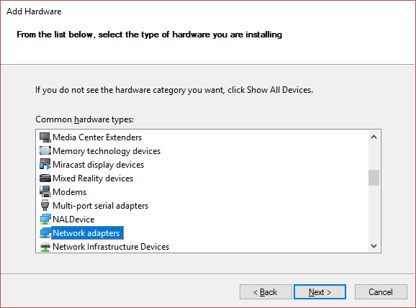

7. Select **Microsoft** as the manufacturer, select **Microsoft KM-TEST Loopback Adapter** as the adapter for Windows 10, then click Next.

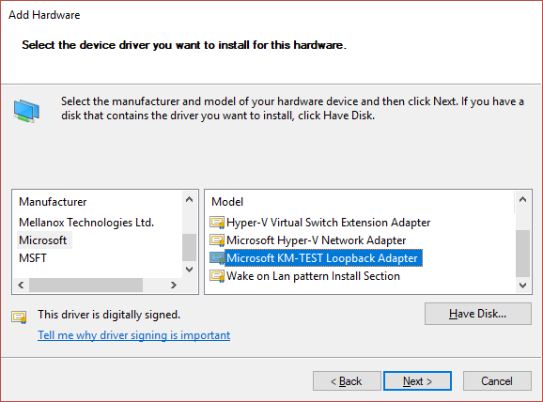

8. Select Next to confirm the installation.

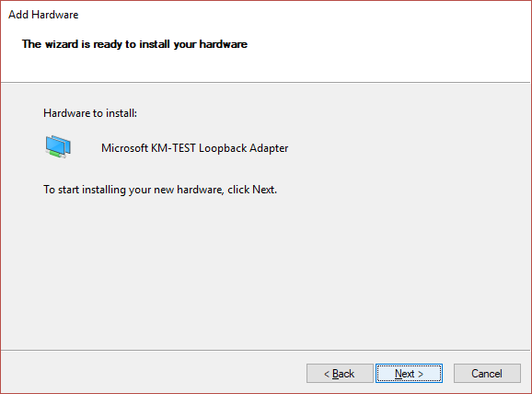

9. Select Finish to complete the installation.

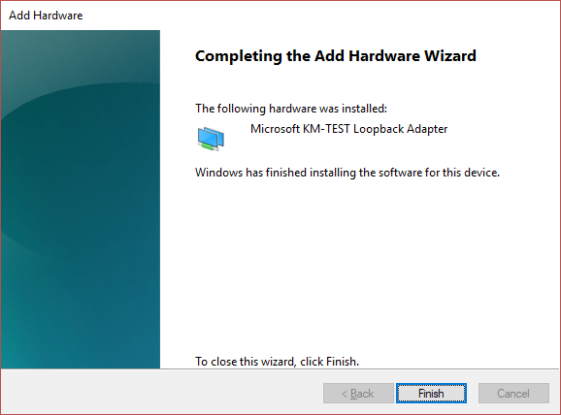

10. Go to your Network Adapters in Control panel and rename the Microsoft Loopback Adapter to just "Loopback".

11. Exit the DreamGrid entirely if it was running, and then start it again. A black DOS box will appear as DreamGrid automatically configures your Loopback adapter.